**Introduction**

We are going to test the design and the ease of use of 2 different prototypes of the same application. It is an app that enables users to book ticket for bus or train from their smartphone, find routes and nearby stations.

The primary functions of this application will be:

* To select users location: typing or using google maps
* Select destination location: typing or using google maps
* Select means of transport: Bus or Train
* View available routes of selected destination
* Find nearby stops using user’s location using google maps
* And checking how often the bus or train leaves the station.

We are going to test how effectively you can perform this tasks, how easily is to browse through our app and find information.

**Methodology**

The test was done in the university’s lab using Balsamiq. For the usability test, 4 individuals were used to do the prototype testing. They were computer science students and tutor labs, 3 males 1 female. I divided them into 2 groups the students and the tutors.

They were given some description of the prototype app to explain what the goal of the application is and some instructions that can be found in Appendix. Then they started to do the test. The 1st group of 2 students tested the main prototype and the 2 tutors the alternative prototype in order to avoid the testers get familiar with one of the prototypes.

The scoring method that was used was the System Usability Scale (SUS). It consists of a 10 item questionnaire with five response options for respondents; from strongly agree to strongly disagree.  It allows us to evaluate a wide variety of products and services, including hardware, software, mobile devices, websites and applications.

**Benefits of using a SUS**

SUS has become an industry standard. The noted benefits of using SUS include that it:

* Is a very easy scale to administer to participants
* Can be used on small sample sizes with reliable results
* Is valid – it can effectively differentiate between usable and unusable systems

Python was used for the data analysis and statistics. First we checked both of the data if they are normal using the shapiro function. Then we used t-test to find whether or not the difference between two groups’ averages reflects a “real” difference in the population from which the groups were sampled. T-test was used because both data are normal. Then we found the estimated range of average and plotted the graphs with the results.

**RESULTS**

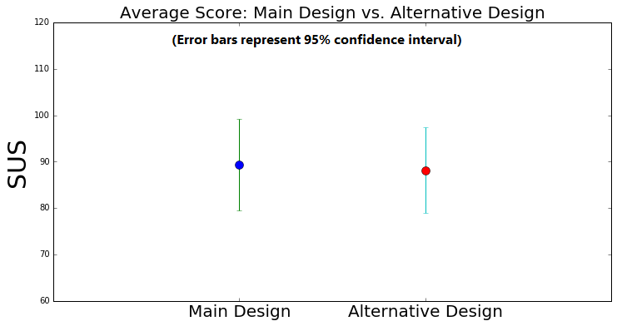

The analysis of the data showed that both of data are **normal**. T-test was used to find the difference between the 2 prototypes. There is no significant difference: p = 0.66, so p > 0.05. The prototypes should be redesigned in order to draw conclusion. But both of designs have high SUS score.

**Main design:** We are 95% confident that the true mean context lies within the interval 79,49 – 99,25.

**Alternative design:** We are 95% confident that the true mean context lies within the interval 78,87 – 97,37.

**DISCUSSIONS AND CONCLUSIONS**

The whole process of the usability test game me a good insight of what the users think about the 2 design prototypes and how easy it is to use them. Although there are few things that I would have changed or done in a different way. Before starting the designing process I would have done a research about what the users would like to see at an application like this so I can have a better idea of my designing process at the beginning. The 2nd thing is that I would have tested my designs with more users because 4 people are a very small number to extract safe results. Additionally I would have tested the prototypes not only with computer literate testers but also with regular people without any computer knowledge but that wasn’t possible in my case. Although there is no significant difference between the prototypes I would choose to redesign the alternative prototype because it has higher SUS and the testers seemed to like and understand better this design.

**Conclusion:** because p > 0.05, there is no statistically significant difference between the average SUS of the in Main prototype and the Alternative prototype.

**APPENDIX-WRITTEN INSTRUCTIONS TO THE PARTICIPANTS**

Hi everyone, thank you for taking the time to participate in this study. Before we begin, I’m going to give you a brief overview of the test and how it will work.This session is pretty straightforward.  I’ll be giving you a broad task to complete and then asking questions as we go along. Before I tell you the task, I’ll be giving you a little bit of context behind it, such as why you might be doing it and what you hope to achieve.It’s really important to know that we are only testing the application not you. You can’t do or say anything wrong here. Please feel free to let me know at any time if there’s something you like, dislike, if you’re confused, etc. Also, I’d like you to “think aloud” as much as possible. By that, I mean that I’d like you to speak your thoughts as often as you can. For example, you may be looking at a page, suddenly see something you didn’t see before and want to click on it. In that case, saying something like “this caught my eye so I’m going to see what it is” would be very useful.

Today we’ll be showing you a prototype of a new experience and asking for your feedback

* We call this a usability study
* This prototype is a rough mock up that is not yet built
* The reason we’re showing you this is to get feedback before the team builds the real version
* Don’t worry about breaking anything

If at any point you have questions, please don’t hesitate to ask. The test will not take more than 5 min and you can stop at any time you want. Do you have any questions so far?Ok, Let’s get started.